
Media Literacy Written Analysis
Please read this entire instruction sheet.
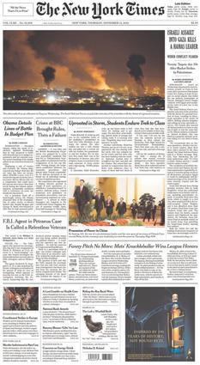
Topic: In this assignment, you will analyze variable coverage of a story in the news media.
Goals of this Assignment:
- Demonstrate your ability to conduct research and evaluate sources.
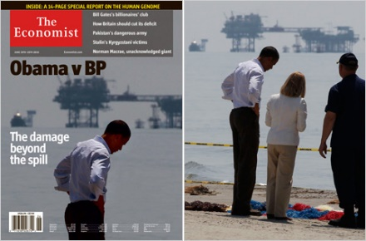
- Demonstrate your ability to present information from a variety of perspectives.
- Demonstrate the skills of media literacy.
Instructions and Content:
- Identify a current news story or topic that has been covered by liberal, centrist, and conservative media on the AllSides website (https://www.allsides.com/unbiased-balanced-news). “I was thinking about immigration (https://www.allsides.com/topics/immigration?search=immigration#gsc.tab=0&gsc.q=immigration&gsc.page=1)
- Read the coverage of the story or topic from the “left” and the “right” not to see which interpretation you agree with, but to be able to explain differences in the coverage.
- Write your analysis using the following outline:
- Introduction: Explain the news story and topic objectively for your audience. You may need to provide additional information on the issue, event, or people involved.
- Analysis:
  - SUMMARIZE the [liberal or conservative] article and its main points so your audience understands.
  - SUMMARIZE the [other] article and its main points so your audience understands.
  - ANALYZE: Identify two or three clear differences in the coverage for your audience, and how (or whether) that fact, position or interpretation was justified in the articles.
  - EVALUATE: Explain which of the articles presented a more convincing approach to the news story – not which article you happen to agree with.
- Conclusion: Carefully explain what lesson about rhetoric and civil discourse you and the audience can take away from this comparison.
- Sources: List your TWO ARTICLES, the JOLLS & JOHNSEN article, and any other sources you used, in a Works Cited List using any standard citation format. (A sample is provided on D2L.)
Requirements:
- Type and submit in Word format.
- Present all article titles and quoted material in quotation marks. Include all sources in the Works Cited list using any standard citation format. (A sample is provided on D2L.)
- Use many paragraph breaks.
- Minimum word count: 700 words. Your name, header information, and Works Cited list do not count.
- Submit to D2L dropbox by posted due date. Do NOT submit as a PDF.

